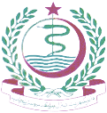 | DIRECTORATE GENERAL HEALTH SERVICES  PUNJAB LAHORE  24-Cooper Road, Lahore    Ph. 042 -99200990; email: hmis.pb@yahoo.com |  |  | 

DHIS-2 Weekly Bulletin Week 42 October (14~20) 2024
  It is a matter of great Pleasure for me to write this message. The impor- tance of data planning and implementation is immense. DHIS is a dici sion support system that will help managers at all  levels to make evidence based decisions. It will help in planning & development, strategy management, Budgeting and forecasting about future needs. The MIS team is praise- worthy to implement the system in the whole province and bring reporting regularity to more than 97%.  The performances of the district man- agement teams and health facilities of the province are available for scrutiny and eval- uation on DHIS. The issues of data validity and data accuracy needs more eﬀorts and hard working The doctors and paramedics should pay heed to the plight of data quality and accuracy, so that correct and valid fig- ures may be made available for the decision makers.  Dr. Muhammad Ilyas Gondal Director General Services Punjab    The weekly Bulletin would have not been possible without support, guidance, and expertise of Dr. Mu- hammad Ilyas Gondal, Di- rector General Health Services Punjab. The regular reviews, discussion, and  modification of methodological framework used to ensure that the Weekly Bulletin meets the most rigorous statistical standards and ac- curately reﬂects the status of our Provincial health system.  On behalf of MIS team, Dr. Khalid Mehmood (Director MIS), Dr. Muhammad Mohsan Wattoo (ADHS-MIS) Mr. Farooq Ahmed (CPO MIS) and Miss Rukhsana Fawad (Data Analyst) thank to the focal persons of Districts and public health professionals who worked to improve our provincial health infor- mation system with their tireless eﬀorts and collaboration and deserve deepest apprecia- tion for continuing eﬀorts, to be better orien- tation to address the public health challenges of today and tomorrow.  Dr. Khalid Mehmood  Director Health Services (P&D and MIS) |  | Key Findings: Health Indicators Analysis:  During the 42nd week of 2024, our data report underwent a thorough analysis, revealing invaluable insights. Through the careful examination of charts and graphs, key patterns and metrics were illuminated.  In Week 42 of 2024, the reporting compliance across all 36 Districts stood at 91%, reflecting a slight decline compared to the previous week's 94%.  The total number of OPD visits during Week 42 was impressively high, totaling 2,316,555 visits compared to the previous week's 2,295,515 visits in Week 41. Notably, new OPD patients comprised 96%, while follow-up visits accounted for 4%.  In terms of facility types, the average daily OPD visits were notably higher in THOS, with 1,311 visits per day. The highest number of OPD visits were reported in District Lahore, which led with 280,616 visits, closely followed by Faisalabad (189,395) and Multan (119,039) in terms of patient footfall.  In the analysis of OPD visits during Week 42nd, there was a slight shift in gender distribution, with females representing 55% of visits and males 45%. Interestingly, the age distribution remained consistent, with the majority of visits coming from individuals aged between 15 and 49 years old.  This week, DHIS-2 documented a total of 68 diseases, encompassing 53% of all patient cases. Among the reported illnesses, communicable diseases constituted 54%, showcasing a slight increase, whereas non-communicable diseases accounted for 46%.  Regarding healthcare procedures, this week saw a total of 112,662 indoor admissions recorded, with 60% of patients admitted due to specific diseases. A total of 24,347 surgeries were conducted with anesthesia, distributed as follows: General Anesthesia (GA) was used in 20% (4,831) of cases, Local Anesthesia (LA) in 50% (12,270), Spinal Anesthesia in 26% (6,220), and alternative anesthesia methods in 4% (1,026).  Within the maternal health domain, ANC visits totaled 204,000 in Punjab for Week 42, with ANC-1 (n= 68,053) reporting 16% (11,289) with Hb<10g/dl. Deliveries numbered 23,754, comprising 78.4% Normal deliveries, 21% C-Section, and 0.34% Vacuum/Forceps. Among the live births (23,422), 1% babies were born with LBW <2.5 kg, and 0.4% were Premature Births. Tragically, 3% (595) of the babies faced specific complications and did not survive. We've also compiled data on Live Births with Low Birth Weight (LBW) under 2.5kg and Premature Births, comparing it with data from previous weeks. We've also tabulated data regarding Kangaroo Mother Care (KMC) for newborns to monitor its implementation and impact.  Moreover, 49,591 Family Planning (FP) visits were recorded during the week, with 74% occurring in BHUs. Districts Faisalabad, Chakwal and Sialkot recorded the highest FP visits, with 3,805, 3,712, and 3,343 FP visits, respectively.  In Week 42, the overall indicators showed mixed trends compared to the previous week. While OPD visits and indoor admissions experienced an upward trend, ANC-1, deliveries, and family planning visits saw a downward trend. | Diseases on high alert in Punjab during the week-42, 2024  Punjab Map - OPD Compliance Reporting Rate  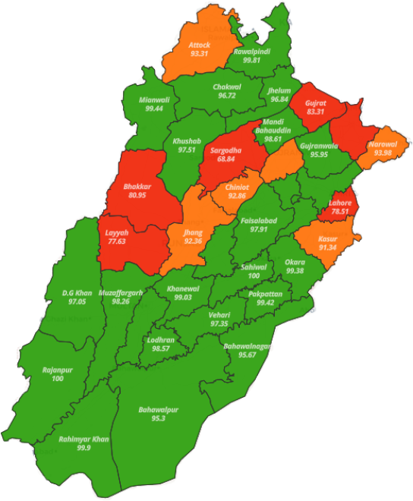  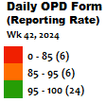  Punjab Map - IPD Compliance Reporting Rate  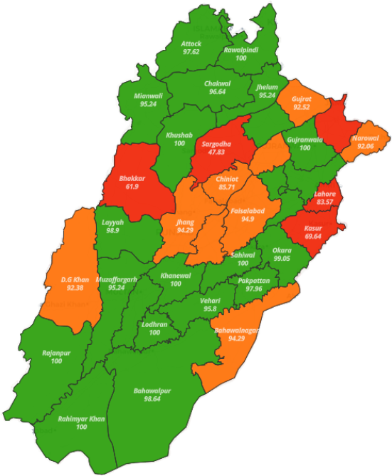  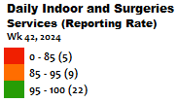  Punjab Map - RMNCH Compliance Reporting Rate  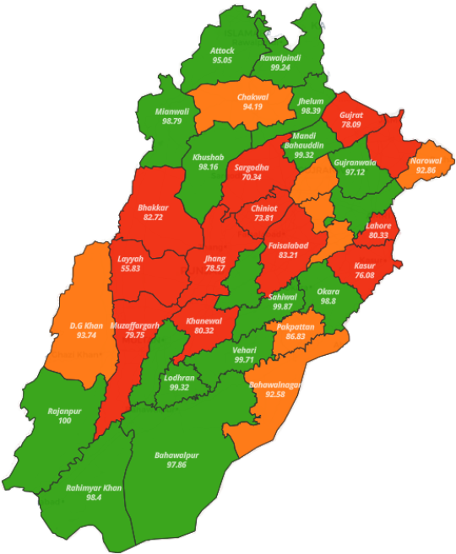  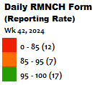
  Dengue | Pneumonia (SARI)
  Diphtheria | Scabies
  Meningitis | Seasonal Influenza
  MERS-COV | Neonatal tetanus
  Reporting Compliance

OUT PATIENT Detail:
Weekly Bulletin: Week 42, October (14~20), 2024

Age and Gender Wise Analysis:  Total OPD 2,316,555 visits were recorded in this week there were more females (55%) visits than that of males (45%). The majority of patients in this context fell within the age range of 15 to 49 years old. | Referred patients:  Total Referred Patients: 3,302  Outgoing Referrals: 38% (1,271 patients) were referred out to other healthcare facilities or institutions.  Incoming Referrals: 62% (2,031 patients) were referred into the healthcare facility from other sources.  Source of Referrals:  Referred from LHW: 71% (1,443 patients)  Referred from Other HFs: 29% (588 patients)
OPD Visits Week Wise Comparative Analysis:  During the week-wise comparative analysis of OPD visits over the past weeks, Week 36 stood out with the highest turnout, reaching 2,388,577 visits. In current week marked a 1 % increase in OPD visits compared to the previous week. |  | Average OPD per day visits:  In the assessment for week 42, the analysis showcased that, according to the bar chart, THOS facilities stood out with the highest daily average of 1,311 OPD visits among various facility type.
Specialty wise OPD cases:
The distribution of OPD visits by specialty is illustrated in the graph.

INDOOR PATIENT Detail
Age and Gender Wise Analysis: | Surgeries with type of Anesthesia:

Suspected Diseases (OPD & INDOOR):
Suspected OPD Disease wise Cases Tabulation:

Communicable and Non-Communicable Diseases:
In Week 42 of 2024 in Punjab, there was a notable incidence of major communicable diseases. Acute Upper Respiratory Infections (AURI) accounted for a significant 64% of cases, indicating a concerning trend. Following closely behind were cases of diarrhea/gastrointestinal issues at 12%, and scabies at 11% of the total cases. Conversely, among non-communicable diseases, the major issue was fever of unknown origin, comprising 33% of cases. This was followed by incidents of peptic ulcer and hypertension, contributing both at 11% to the total caseload, respectively. These insights were gathered from patients seeking medical attention in outpatient departments for both communicable and non-communicable diseases during this period.
Week wise Comparison of Suspected OPD Communicable Diseases:

INDOOR Disease wise Admission:
IRMNCH:
ANC Detail:  Among the total 204,000 ANC visits in this week, ANC-1 constituted 33% (68,053) with 17% (11,289) showing Hb<10g/dl, while ANC-2, ANC-3, and ANC-4 comprised 31% (62,748), 19% (39,722), and 16% (33,477) respectively. |  |  |  | Weekly Comparison of Anemia among Women Attending First Antenatal Care:
The trend analysis of pregnant women receiving their first antenatal services shows notable fluctuations over the observed weeks. Week 36 recorded the highest ANC-1 visits with 81,817 women. In the current Week 42, there was a significant 8% decline in ANC-1 visits compared to Week 41. Additionally, the number of anemic women attending first antenatal care rose over this period.
Exploring Weekly Delivery Method Trends:
Out of a total of 23,754 deliveries, 78% were normal, 21% were C-sections, and only 0.34% involved the use of vacuum or forceps. Analyzing weekly patterns in delivery methods revealed that Week 36 experienced the highest number of deliveries, while Week 35 saw the lowest. In the current Week 42, there was a 5% decline in deliveries compared to the previous week

 |  | Comparative weekly Analysis of Total Deliveries, Live births and PNC-1 Visits:
Live Births and Maternal Deaths:
This week, we tragically recorded 04 maternal deaths. Of these, 1 was due to Rapture Uterus. Additionally, out of 23,422 total live births, 3% (5951 newborns) did not survive due to complications during childbirth.
Live Births and Maternal Deaths:  This week, we tragically recorded 04 maternal deaths. Of these, 1 was due to Rapture Uterus. Additionally, out of 23,422 total live births, 3% (5951 newborns) did not survive due to complications during childbirth. |  |  |  | Neonatal Deaths with Complications
Kangaroo Mother Care (KMC) Newborn Indicators

Maternal and Child Health Metrics Overview:  The bar graph illustrates key maternal and child health indicators The data represents a comprehensive assessment of healthcare utilization and outcomes across various stages of the maternal and child health field | Family Planning:  In the 42nd week of 2024, there were 49,591 family planning visits. Of these, 2% (854) were by women under 25, and 66% (32,656) were new clients. Counseling visits accounted for 20% (9,807), with 85% being new clients and 15% returning. Referrals by LHWs made up 9% (4,358), postpartum visits 5% (2,625), and post-abortion visits 1% (376).  Regarding the methods used during family planning visits, condoms were the most common 51% (20,340), followed by COC cycles 25% (9,843). Less popular methods included POP cycles, tubal ligation, and implants.
Week wise Family Planning Visits:  In Week 42, Family Planning (FP) visits decreased by 3%, reaching 49,591 compared to 51,248 in Week 41. The highest visits were recorded in Week 36 at 50,798, with the data showing a fluctuating pattern over the weeks. |  |  | Family Planning by Health Facility type wise:  This graph illustrates the distribution of FP visits across different Health Facility types. The largest share, comprising 74% of the total visits, took place in BHUs, followed by RHCs at 15%, THQs at 6%, DHQs at and THOS at 3% and 2% respectively.

